INFOSHEET THE WAVE:
BIOGRAFIE:
The Wave speelt jazz, funk- en soulcovers of populaire hits. Een wisselend collectief van multi-getalenteerde muzikanten en artiesten, ze zijn toegewijd aan het brengen van nieuw leven, nieuwe grooves en nieuwe energie voor bekende deuntjes. The Wave heeft gespeeld in clubs rond Amsterdam, Londen, Europa en het Midden-Oosten.

The Wave is te boeken vanaf 3 personen (zanger/pianist, bassist en drums) en uit te breiden met gitaar.
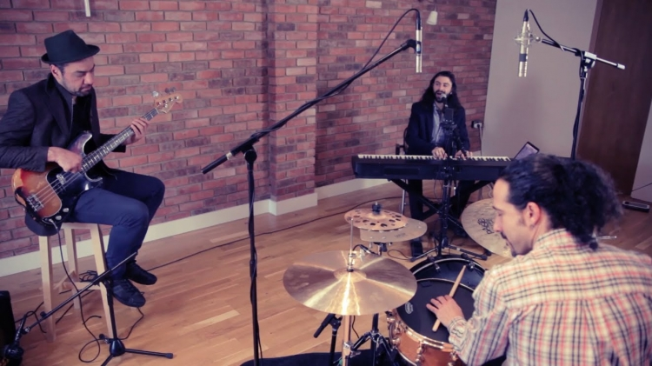
FACTS:
- The Wave speelt 3 x 45 min
- Perfect voor een feest, bruiloft, dinner, receptie, borrel, opening
- 3 personen: zanger/pianist, contrabas en drums
- Genre: Jazz, Pop, Soul, Worldmusic

KLIK HIER VOOR VIDEO

GREEP UIT HET REPERTOIRE:

3 Birds - Bob Marley
A La La La La Long - Innercircle
A thousands Years - Christina Perry
Ain’t No Sunshine - Bill Withers
All Of me - John Legend
Another Day - Buckshot Lefonque
Another Day - Jamie Lidell
Beggin - Madcon
Billy Jean - Micheal Jackson
Black Birds - Beatles
Can you love me again - John Newman
Clocks - Coldplay
Could You Be Loved - Bob Marley
Crazy - Gnarls Barkley

Diamonds - Rihannah
Don’t Know Why - Norah Jones
Don’t Panic - Coldplay
Don’t you worry bout a thing - Stevie wonder
Don’t You Worry Child - Swedish Mafia
Englishman in New York - Sting
Everybody gotta learn sometimes - Beck Hansen
Everything - Michael Buble
Fast Car - Tracy Chapman
Georgia - Ray Charles
Get Lucky - Pharrell/Nile Rodgers
Golden - Jill Scott

Happy - Pharrell
Higher Ground - Stevie Wonder
Human Nature - Michael Jackson
I can’t Feel My Face - The Weekends
I can’t help It - Michael Jackson
I Feel Good - James Bropwn
I heard it Through The Grapvine - Marvin Gaye
I Love You Just The Way You Are - Bruno Mars
I Shot The Sherriff - Bob Marley
I wanna Hold your hand - Beatles
Is this Love - Bob Marley
Isn’t She Lovely - Stevie Wonder

INFOSHEET THE WAVE:
BIOGRAPHY:
The Wave plays smooth, jazz inflected funk and soul covers or popular hits. A shifting collective or multi-talented musicians and performers, they are dedicated to bringing new life, new grooves and new energy to familiar tunes. The Wave has played at clubs around Amsterdam London, Europe, and the Middle East.

For something really different, but oh so well played, try The Wave!

FACTS:
- The Wave plays 3 x 45 min
- Perfect for a party, wedding, dinner, drinks reception or opening
- 3 persons: singer-pianist, double bass and drums
- Genre: Jazz, Pop, Soul, Worldmusic

CLICK HERE FOR A VIDEO

GREEP UIT HET REPERTOIRE:

3 Birds - Bob Marley
A La La La La Long - Innercircle
A thousands Years - Christina Perry
Ain’t No Sunshine - Bill Withers
All Of me - John Legend
Another Day - Buckshot Lefonque
Another Day - Jamie Lidell
Beggin - Madcon
Billy Jean - Micheal Jackson
Black Birds - Beatles
Can you love me again - John Newman
Clocks - Coldplay
Could You Be Loved - Bob Marley
Crazy - Gnarls Barkley

Diamonds - Rihannah
Don’t Know Why - Norah Jones
Don’t Panic - Coldplay
Don’t you worry bout a thing - Stevie wonder
Don’t You Worry Child - Swedish Mafia
Englishman in New York - Sting
Everybody gotta learn sometimes - Beck Hansen
Everything - Michael Buble
Fast Car - Tracy Chapman
Georgia - Ray Charles
Get Lucky - Pharrell/Nile Rodgers
Golden - Jill Scott

Happy - Pharrell
Higher Ground - Stevie Wonder
Human Nature - Michael Jackson
I can’t Feel My Face - The Weekends
I can’t help It - Michael Jackson
I Feel Good - James Bropwn
I heard it Through The Grapvine - Marvin Gaye
I Love You Just The Way You Are - Bruno Mars
I Shot The Sherriff - Bob Marley
I wanna Hold your hand - Beatles
Is this Love - Bob Marley
Isn’t She Lovely - Stevie Wonder

